Game Design Document

Fill up the following document

1. Write the title of your project.

Marathon Runner

1. What is the goal of the game?

To not hit the obstacles and run as far as possible.

1. Write a brief story of your game.

Jessica decides that she wants to break her highest record of how far she can run, so she decides to set up a marathon. Now she’s going to time herself and see how far she can run without running into any obstacles.

1. Which are the playing characters of this game?

* Playing characters are the ones who respond to the user based on the input from the user.
* Cars, monkeys, dinos, wizards, etc., are the playing characters in the game.

|  |  |  |
| --- | --- | --- |
| Number | Character Name | What can this character do? |
| 1 | Jessica | Run as far as she can |
| 2 |  |  |
| 3 |  |  |
| 4 |  |  |
| 5 |  |  |
| 6 |  |  |
| 7 |  |  |
| 8 |  |  |

1. Which are the Non-Playing Characters of this game?

* Non-Playing characters are the ones that don't have an action or behavior when the user interacts with the game.
* Hurdles, stones, bananas, coins, etc., are non-playing characters in the game.

|  |  |  |
| --- | --- | --- |
| Number | Character Name | What can this character do? |
| 1 | hurdles | Cause game over if Jessica runs into this |
| 2 | rocks | Cause game over if Jessica runs into this |
| 3 |  |  |
| 4 |  |  |
| 5 |  |  |
| 6 |  |  |
| 7 |  |  |
| 8 |  |  |

Draw your imagination of this game. What does this game look like?

* Draw the game either on your computer or on paper.
* Add images of the game scenes to show each of the playing and non-playing characters at least once.

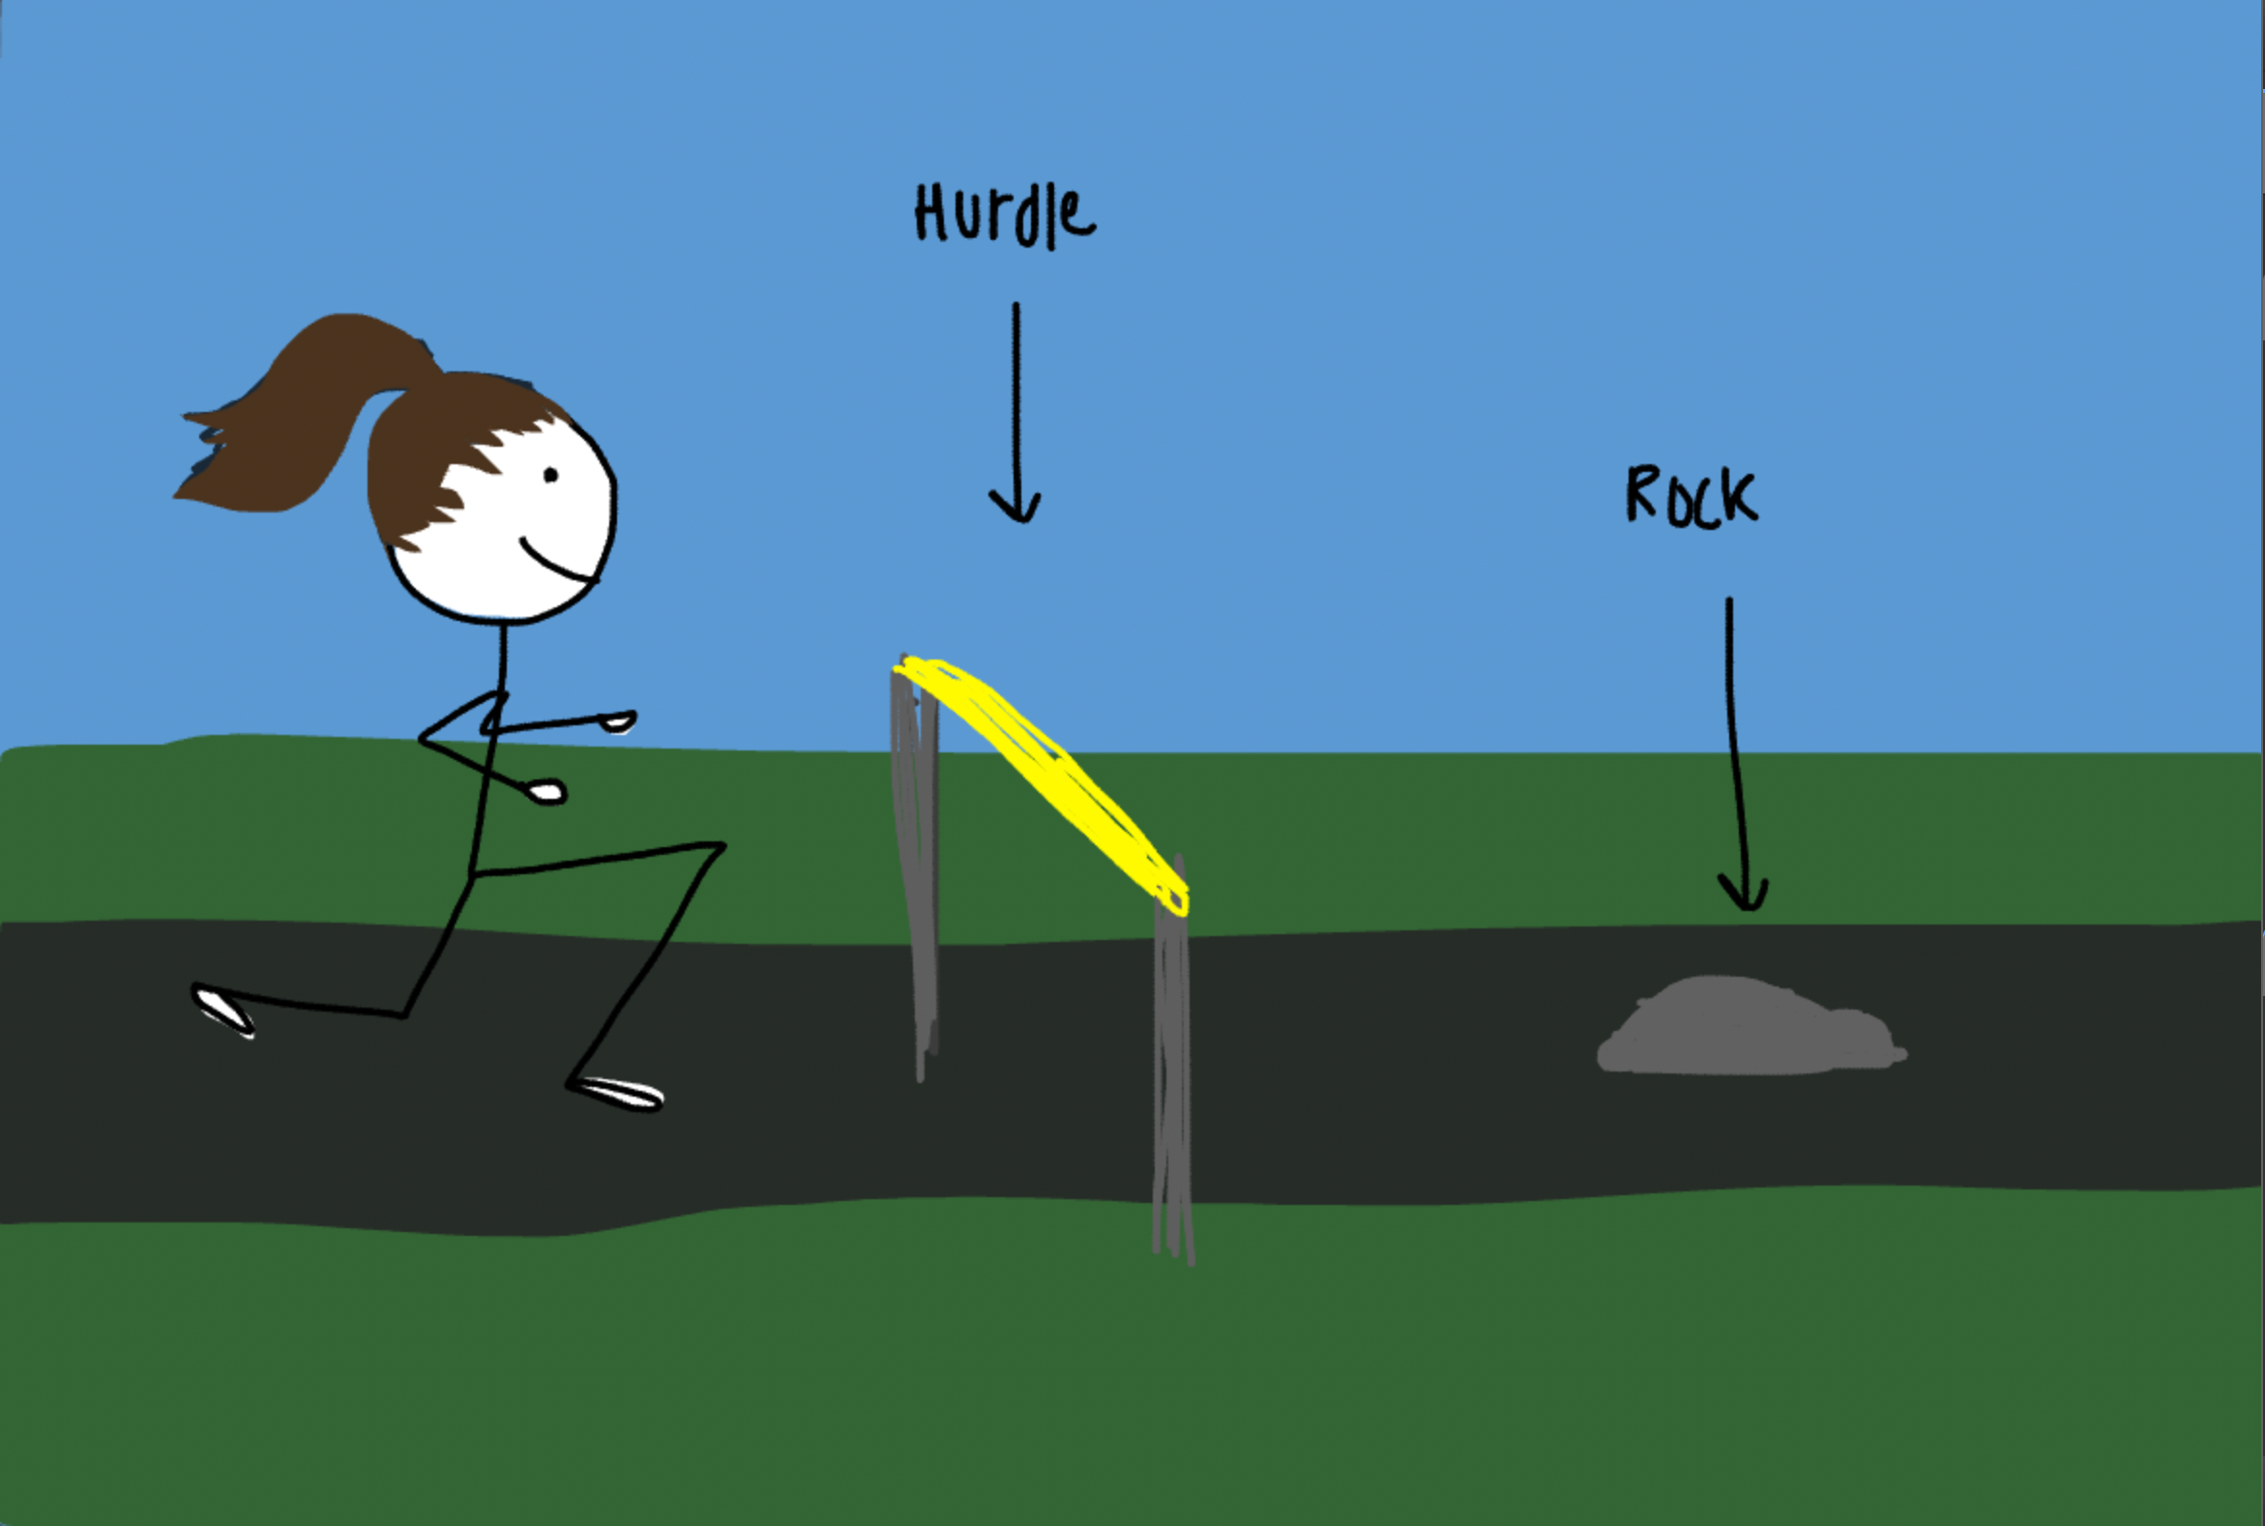

How do you plan to make your game engaging?

To make this game harder and not boring for the player, I will increase the speed after every 400 points.